Japanese Pitch accent Trainer
Project Research

Hafza Abdullahi
4th year Software Dev Student
submission date: 23/10/2025

Contents
Linguistic foundations of the japanese pitch accents 3
Visual feedback and learning 3
Spaced repetition learning 3
Frequency Extraction Using Parselmouth python 4
Acoustic Parameter Optimization 4
graph smoothing and signal processing 6
Error detection in pitch for users 7
Dynamic Time Warping for Pattern Comparison 7
Development 8
Flutter Cross-Platform Development 8
Backend API Architecture with Python/Flask 8
Firebase Authentication & Security 8
Relevent overall research about waves and frequency 9
References 10
Links 10
FIGURES 12

Linguistic foundations of the japanese pitch accents
Japanese pitch accent is often described as significant acquisition barrier for second language learners, especially those from non-pitch accent languages. English has a stress accent which uses the loudness and duration where as Japanese uses pitch changes, according to Kanshudo [1] Japanese is “rhythmic” and jumpy with abrupt pitch changes between words, there are 4 main types of pitch changes in Standard Tokyo Japanese: Heiban, Atamadaka, Nakadaka and odaka. Each one is uniquely different and some words that are similar, can have different meanings depending on how it was pronounced. These patterns are phonemic, for example, pairs like "hashi" (箸 chopsticks: HIGH-LOW) versus "hashi" (橋 bridge: LOW-HIGH). Usually using the context of a sentence, you can assume what someone meant even if they used the wrong pitch accent but that’s not always the case.
The Four Pitch Patterns
- Heiban (平板): Low-High pattern (e.g., "iku" 行く meaning to go)
- Atamadaka (頭高): High-Low pattern (e.g., "hashi" 箸 meaning chopsticks)
- Nakadaka (中高): Low-High-Low pattern (e.g., "otoko" 男 meaning boy/male)
- Odaka (尾高): Low-High pattern with final drop (e.g., "sakura" 桜 meaning cherry blossom)

Visual feedback and learning
The study By Offerman and Olsen in 2016 provides crucial insight into the effectiveness of visual feedback in second language acquisition, their research shows that using speech analysis tools, learners can grasp what they are saying and get better overtime at more accurate pronunciation.

Spaced repetition learning
Spaced repetition is a learning technique that demonstrates information is better retained when study sessions are distributed overtime, rather than concentrated into a few single sessions sporadically. The flashcard Anki is a great example that implements this well. As a Japanese learner and Anki user I’m passionate about this learning technique and its effectiveness. This concept originates from Herman Ebbinghaus’s 1885 research on memory, focusing on the “forgetting curve” which shows how information retention declines exponentially overtime
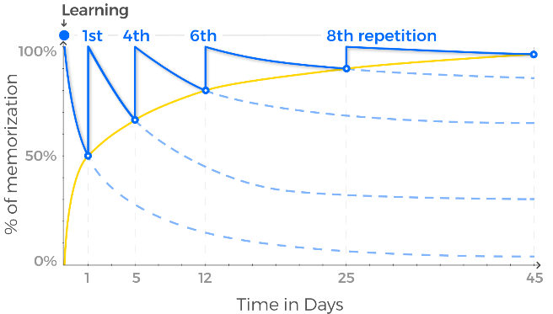
Figure 1 The forgetting curve by Hermann Ebbinghaus
Spaced repletion counteracts this by strategically timing review sessions of study material like flashcards just before they would naturally fade, this strengthens neural pathways and enhances long-term retention. Language learning benefits greatly from this, as learning and remembering vocab and kanji long term for Japanese takes a few review sessions and a lot of immersion.
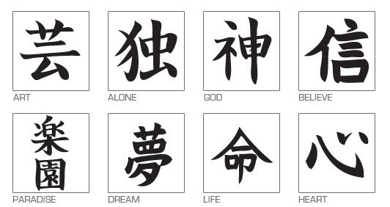
Figure 2 “100 of the most common kanji characters”

Frequency Extraction Using Parselmouth python
Parlselmouth is a python library for pitch and frequency extraction made for the praat software [4] based on the autocorrelation methods [5] . It provides tools for detailed speech analysis from recording or real time. This is done in multiple ways

Acoustic Parameter Optimization
- Pitch detection range: 75-600 Hz, accommodating gender and age variations in vocal frequency

- Time resolution: 10ms intervals, sufficient for capturing mora-level transitions

- Voicing threshold: Optimized for Japanese vowel characteristics and duration patterns

Example graphs using parselmouth python library I made using the word “iku” said by me, compared to a native female speaker pitch accent dictionary website [6]
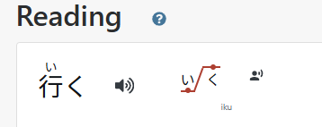
Figure [3] showing the pitch change in “iku” from low to high

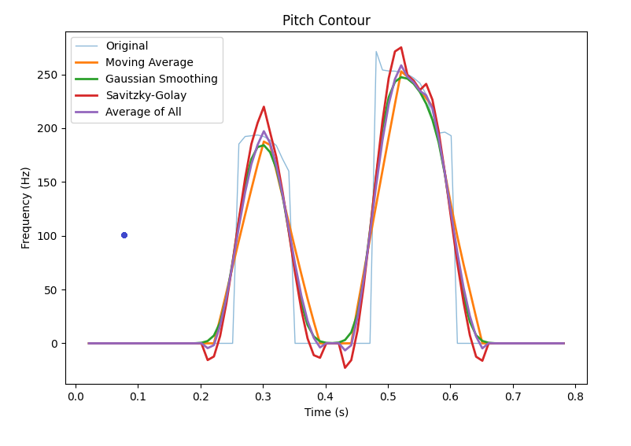
graph showing the pitch change in the word iku, speaker: native female [6] img source: my code
These graph shows a clear change in pitch from low to high, the change from the first “i” (low pitch) + “ku” (High pitch)
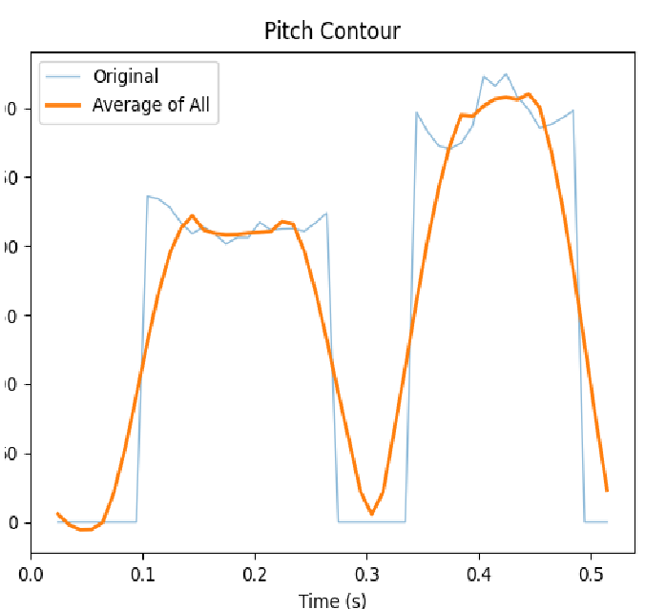
graph showing pitch change in in the word iku, speaker is me img source: my code

graph smoothing and signal processing
Raw pitch extraction contains noise and vocal jitter, recording artefacts. To eliminate this, smoothing of the graph ensures the audio is cleaner more average, so that we can see clear changes in pitch overall
Moving Average Filtering: Provides temporal averaging to reduce high-frequency fluctuations while preserving overall contour shape (Smith, 1997) [8]
Gaussian Smoothing: Applies kernel-based smoothing that maintains natural pitch movement curvature, essential for preserving accent pattern characteristics.
Savitzky-Golay Filtering: Utilizes local polynomial regression to smooth signals while preserving critical features such as peak locations and transition points [9]
The consensus-based approach, averaging results from all three methods, shows clearer and smoother changes across varying recording conditions and speaker characteristics.
Example using the word: “iru” , in this graph both pronunciation (high- low atamadaka ) and (low-high heiban ) pitch patterns can be seen using a native female speakers recording. The average graphs shows a clearer change in pitch
iru ( いる) pronounced using a high low pitch means to need where as, “iru ( いる)” pronounced with low high pitch means to be.
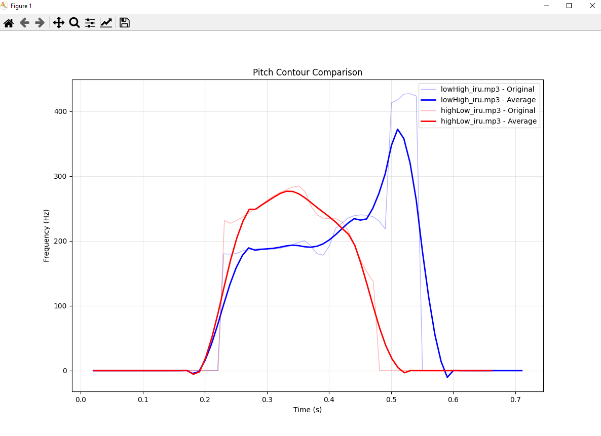
graph showing different pitch changes in in the word iru, speaker is me img source: my code

Error detection in pitch for users
Error classes:
- early_drop - Pitch drops too soon
- late_drop - Pitch drops too late
- no_drop - Missing pitch drop entirely
- wrong_pattern - Used completely wrong accent pattern
correct - Proper pronunciation
pitch accent by x amount of hz to be considered correct alongside Dynamic Time warping

Dynamic Time Warping for Pattern Comparison
Dynamic Time warping (DTW) is a technique for comparing two time series that may vary in speed or timing, by warping the axis to find the best possible alignment. It solves the problem of comparing sequences that are similar in shape but not perfectly aligned. [9] It allows one of the sequences to stretch or compress to match the other, hence the name. This is useful for pattern recognition in words to analyse where the syllable and pitch changes happened, and if it matches up.
Dynamic time warping distances are then converted to percentage similarity scores using derived thresholds, this gives a “correctness scores” of a pronunciation of the given word compared to native speaker/s

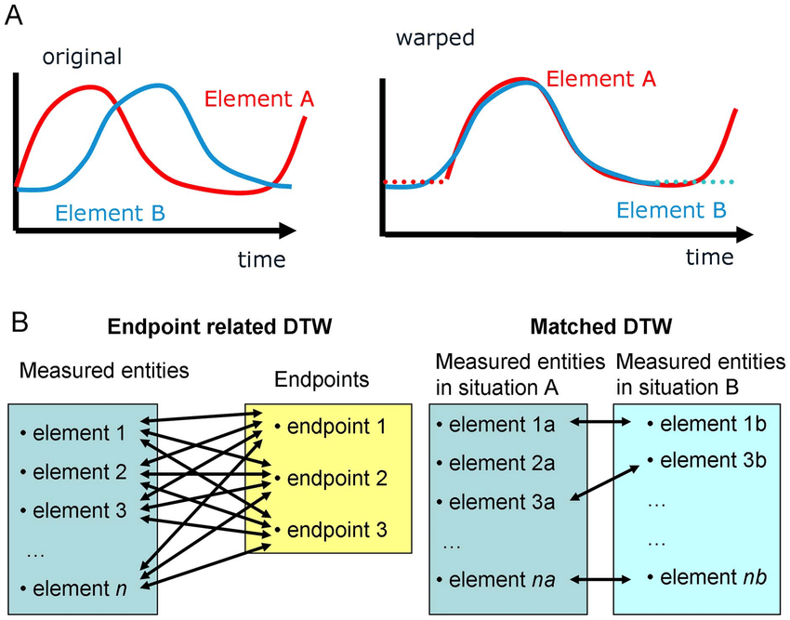
Figure [4] showing Dynamic Time warping

Development

Flutter Cross-Platform Development
Flutter provides a good framework for developing cross-platform mobile applications using Dart programming language. Since I used Flutter/dart and android studio in my last project I am comfortable on the workspace. Flutter is a widget-based architecture that enables consistent UI layouts and rendering.
Key advantages:
- Hot reload feature for rapid development iteration and checks
- Native plugin ecosystem for audio recording and playback
- Single codebase deployment to multiple platforms
- Massive widget library for UI and graphs etc

Feature Implementations:
- Audio Recording: Utilizes audiorecorder or flutter_sound plugins for capture
- Data Visualization: Employs charts_flutter for pitch contour graphing

Backend API Architecture with Python/Flask
Flask is a popular lightweight framework for building RESTful APIs in Python. Flasks supports rapid prototyping and scalability
API Endpoint Architecture:
The API follows REST principles with JSON payloads, providing stateless communication layer between the flutter mobile client and python backend

Firebase Authentication & Security
Firebase provides a NoSQL cloud database with real-time synchronization capabilities.” Firebase Realtime Database and Cloud Firestore provide database services. I listed them both as “realtime, cloud hosted, NoSQL databases”. [10]
Firebase has easier and safer authentication setup with the options of google sign [11] in as well

Relevent overall research about waves and frequency
In wave mechanics, wave speed doesn’t change when frequency changes. It is often misunderstood that changing the frequency of a wave also changes its speed. What changes frequency are oscillations
Wave Speed = Frequency × Wavelength
Wave speed is determined by the medium, the thing the wave is travelling
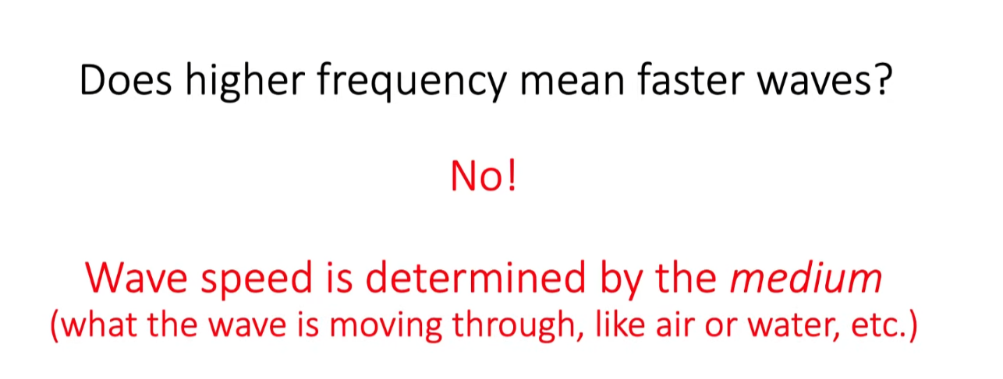
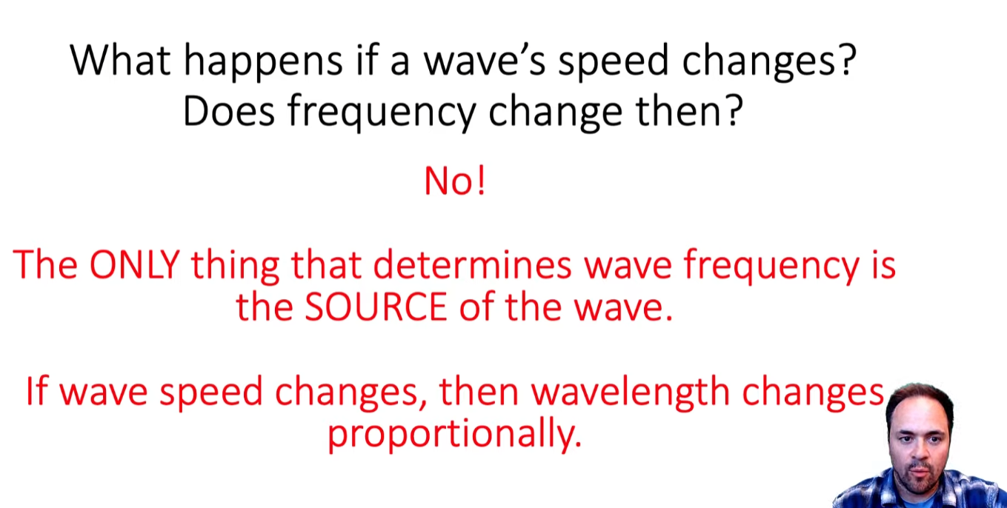
Figure 4 Waves - Frequency, Speed, and Wavelength YouTube video by Jon white
How are frequency and wavelength related?
- High Frequency results in a Short Wavelength.
- Low Frequency results in a Long Wavelength. [12]

References

Links
- [1] Kanshudo Pitch accent site https://www.kanshudo.com/howto/pitch accessed 18/10/2025

- [2] Science Direct, July 2016 https://www.sciencedirect.com/science/article/abs/pii/S0346251X16000373 accessed 18/10/2025

- [3] The forgetting curve: Hermann Ebbinghaus, 1885 https://www.taalhammer.com/the-forgetting-curve-hermann-ebbinghaus/ accessed 18/10/2025

- [4] Parselmouth praat , https://parselmouth.readthedocs.io/en/stable/ accessed 19/10/2025

- [5] Auto correlation methods, Boersma, 1993 https://www.fon.hum.uva.nl/paul/papers/Proceedings_1993.pdf accessed 19/10/2025

- [6] Pitch accent dictionary, https://www.gavo.t.u-tokyo.ac.jp/ojad/search accessed 20/10/2025

- [7] smoothing average, Steven W. Smith https://www.dspguide.com/ch15/5.htm accessed 20/10/2025

- [8] Savitzky-Golay Filter, https://medium.com/pythoneers/introduction-to-the-savitzky-golay-filter-a-comprehensive-guide-using-python-b2dd07a8e2ce accessed 20/10/2025

- [9] Dynamic Time warming, https://link.springer.com/chapter/10.1007/978-3-540-74048-3_4 accessed 18/10/2025

- [10] The medium, what is firebase, Doug Stevenson https://medium.com/firebase-developers/what-is-firebase-the-complete-story-abridged-bcc730c5f2c0 accessed 18/10/2025

- [11] Firebase authentication, https://firebase.google.com/docs/auth/where-to-start accessed 23/10/2025

- [12] Waves - Frequency, Speed, and Wavelength, Jon White accessed https://youtu.be/4yfXp1jNBn8?si=0_yGhUKXm-Bb019K 23/10/2025

FIGURES
- [1] The forgetting curve: Hermann Ebbinghaus, 1885 https://www.taalhammer.com/the-forgetting-curve-hermann-ebbinghaus/ accessed 18/10/2025

- [2] ThoughtCo. 100 common kanji https://www.thoughtco.com/the-most-frequently-used-kanji-2028155 accessed 20/10/2025

- [3] the word iku , https://www.japandict.com/%E8%A1%8C%E3%81%8F accessed 19/10/2025

- [4] Dynamic Time Warping, Jos Kleinjans https://www.researchgate.net/figure/Dynamic-time-warping-Panel-A-shows-how-time-series-can-be-aligned-using-dynamic-time_fig4_256102831 accessed 23/10/2025

- [5] Waves - Frequency, Speed, and Wavelength, Jon White accessed https://youtu.be/4yfXp1jNBn8?si=0_yGhUKXm-Bb019K 18/10/2025

